Management 390 Industry Analysis

Date: Apr. 15, 15

Contemporary: page 207 – 217

Industry Evolution and Strategic Change

# The Industry Life Cycle

* Product life cycle
  + Born
  + Maturity
  + Decline
  + Die out
* Industry life cycle
  + It’s likely longer than a single product
  + Four phases
    - Introduction (emergence)
    - Growth
    - Maturity
    - Decline

## Demand Growth

* S-shaped growth curve
* In the introduction stage
  + Sales are small
  + The rate of market penetration is low
    - Industry’s products are little know and customers are few
  + Novelty of technology, small scale of production, and lack of experience mean high costs and low quality
  + Customers tend to be
    - Affluent
    - Innovation-oriented
    - Risk tolerant
* Growth stage
  + Accelerating market penetration as technical improvements and increased efficiency open up the mass market
* Maturity stage
  + Demand is holly for replacement
* Decline
  + Challenge by new industries that produce superior substitute products

## Creation and Diffusion of knowledge

* Knowledge is the second driver of industry life cycle
  + New knowledge in the form of production innovation
  + Dual processes of knowledge creation and knowledge diffusion exert a major influence on industry evolution

### Dominant designs and technical standards

* Dominant design
  + A product architecture that defines the look, functionality, and production method for the product and becomes accepted by the industry as a whole.
  + It is the outcome of competition between rivals designs and technologies
  + Refer to the overall configuration of a product or system
  + Exist in processes and business models
  + Closely related to the technical standard
* Technical standard
  + A technology or specification that is important for compatibility
  + Emerge where there are network effects
    - The need for users to connect in some way with one another
    - Cause each customer to choose the same technology as everyone else to avoid being stranded

### From product to process innovation

* The emergence of dominant design marks a critical juncture in an industry’s evolution
* Once the industry coalesces around a leading product design
  + There is a shift from radical to incremental product innovation
  + It could be necessary to inaugurate the industry growth phase
    - Greater standardization reduce risks and encourage investment
  + The shift in emphasis from design to manufacture
    - Increased attention to process innovation as firms seek to reduce costs and increase product reliability through large-scale production method
* The combination of process improvement, design modifications, and scale economies
  + Falling costs and greater availability
    - Drive increasing market penetration

## How general is the life-cycle pattern

* Over time, industry life cycles have become increasingly compressed
  + Especially in e-commerce
* Industry’s evolutions are different
  + Basic necessities industry will never enter a decline phase
* An industry is likely to e at different stages of its life cycle in different countries
* A further feature of industry evolution is shifting boundaries of industries

## Implications of the life cycle for competition and strategy

### Product differentiation

* Convergence around a dominant design is often followed by commoditization during the mature phase unless producers develop new dimensions for differentiation

### Organizational demographics and industry structure

* The number of firms in an industry changes substantially over the life cycle
* Organization ecology
  + Analyzes the population of industries and processes of founding and selection that determine enter and exit
  + Main finding

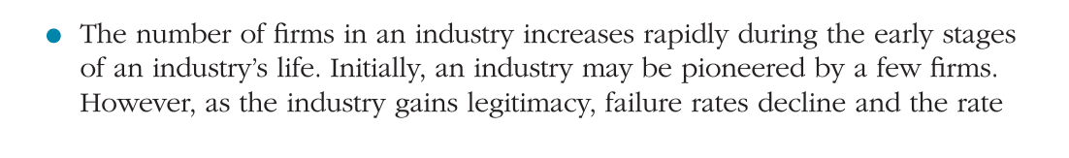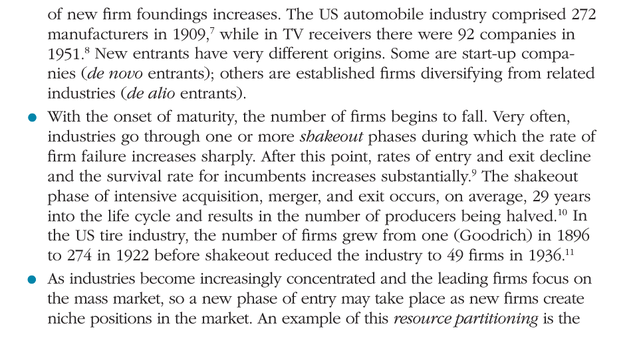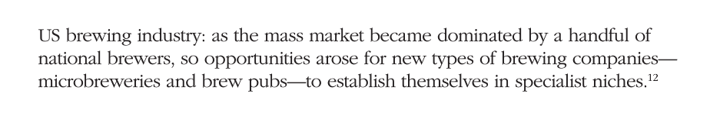

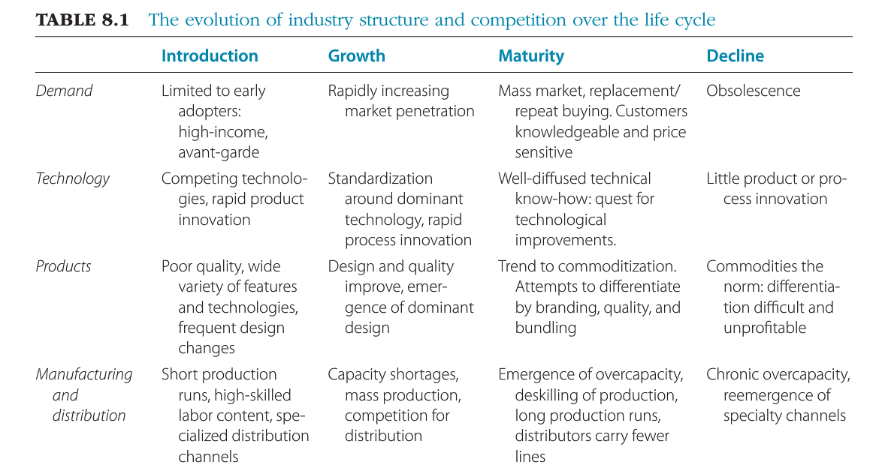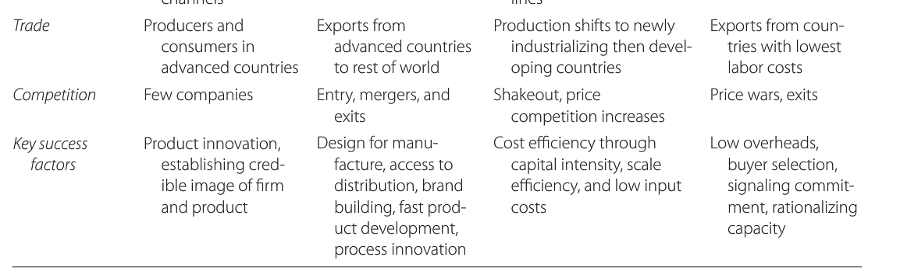

* In different industries structural change follows very different evolutionary paths
* Most industry
  + Maturity is associated with increasing concentration
* In industries where scale economies are unimportant and entry barriers are low
  + Maturity and commoditization may cause concentration to decline
* Some industry
  + First mover can achieve near-monopolies

### Location and international trade

* Industries move internationally during their life cycles as a result of shift in demand decreasing dependence on advanced knowledge

### The nature and intensity of competition

* These changes in industry structure over the life cycle have implications for competition
  + Commoditization
  + New entry
  + International diffusion of production
* Implications
  + Shift from non-price competition to price competition
  + Margins shrink as the intensity of competition grows
* Introduction stage
  + Battle for technology leadership means the price competition may be weak
  + Heavy investments in innovation and market development depress profitability
* Growth phase
  + More conducive to profitability as market demand outstrips industry capacity
    - Especially if incumbents are protected by barriers to entry
* Maturity
  + Increased product standardization and excess capacity stimulate price competition
* Decline
  + Almost always associated with strong price competition and dismal profit performance

### Key success factors and industry evolution

